|  |  |
| --- | --- |
| **Name** | Anish Gade |
| **UID** | 2021700022 |
| **Exp No** | 3 |
| **Date** | 20-02-2023 |
| **Subject** | CCN |

**AIM:** Implement FTP server for given scenario

**Step 1:** Update the system

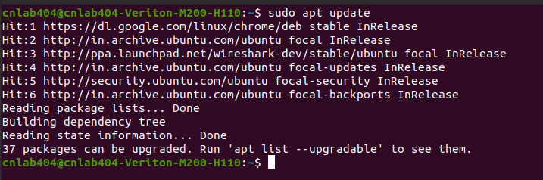

**Step 2:**  Install VSFTPD

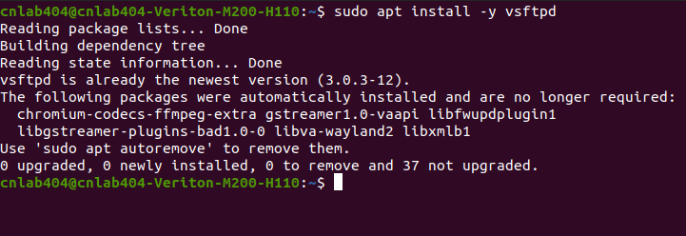

**Step 3:** set up configuration file

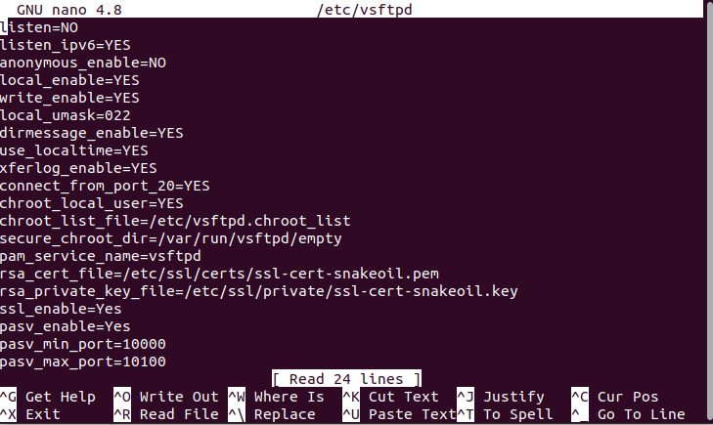

**Step 4:**  Restarting vsftpd and checking it’s status

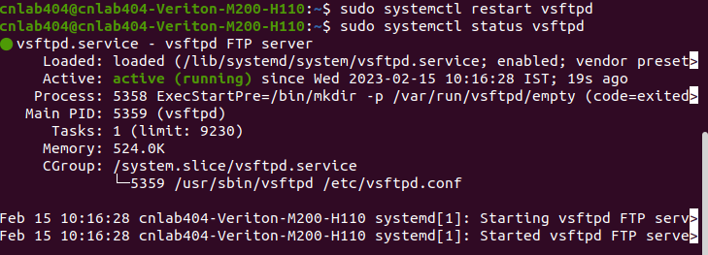

**Step 5:**  Allow to configure

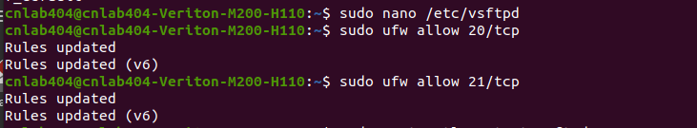

**Step 6:** Adding User

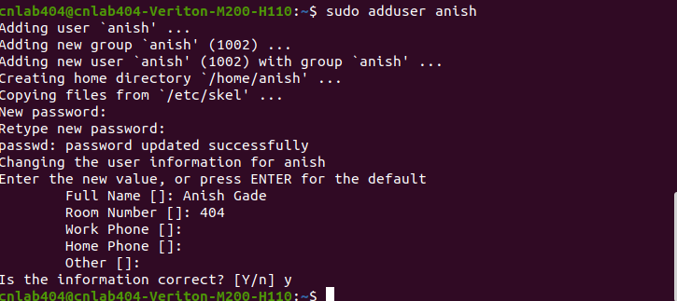

**Step 7:** connecting to server and getting a file

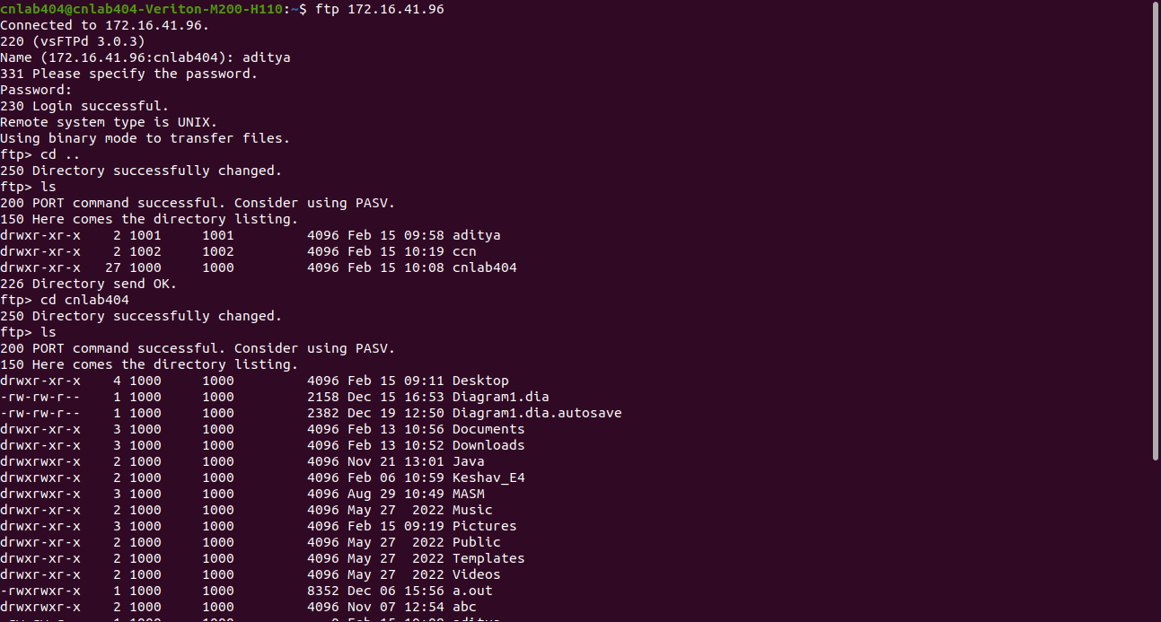

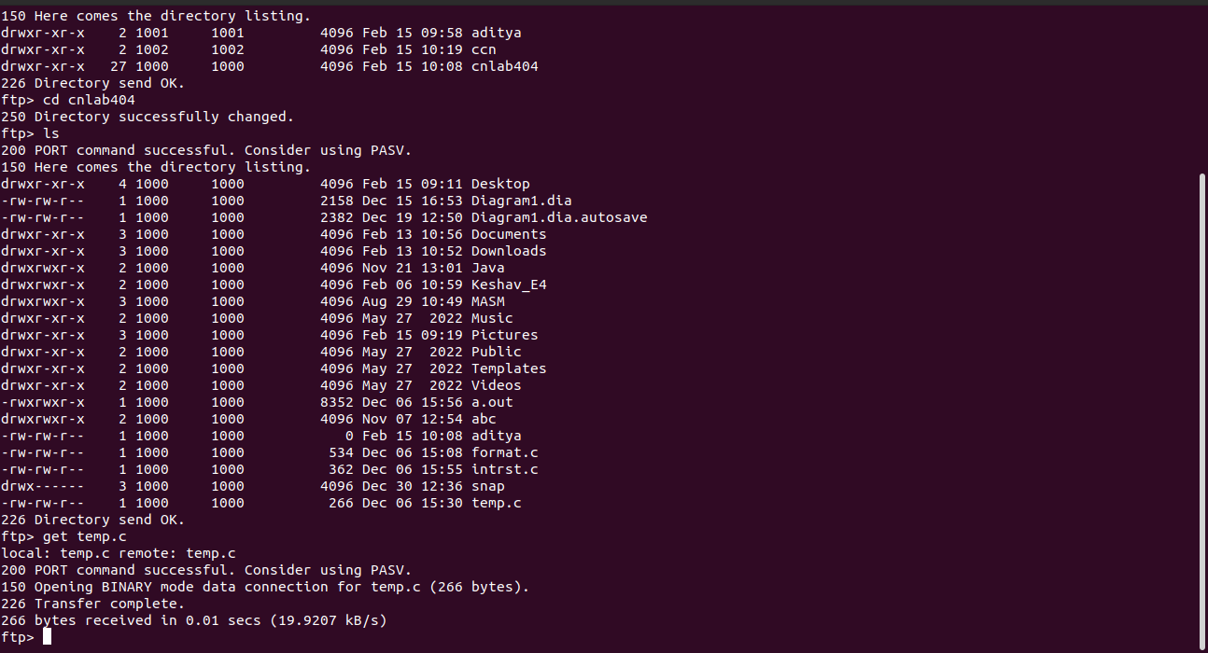

**What is FTP?**

FTP (File Transfer Protocol) is a network protocol for transmitting files between computers over Transmission Control Protocol/Internet Protocol (TCP/IP) connections. Within the TCP/IP suite, FTP is considered an application layer protocol.In an FTP transaction, the end user's computer is typically called the *local host*. The second computer involved in FTP is a *remote host*, which is usually a server. Both computers need to be connected via a network and configured properly to transfer files via FTP. Servers must be set up to run FTP services, and the client must have FTP software installed to access these services.Although many file transfers can be conducted using Hypertext Transfer Protocol (HTTP) -- another protocol in the FTP is still commonly used to transfer files behind the scenes for other applications, such as banking services. It is also sometimes used to download new applications via web browsers.

**What is FTP server?**

An FTP Server, in the simplest of definitions, is a software application that enables the transfer of files from one computer to another. FTP (which stands for “File Transfer Protocol”) is a way to transfer files to any computer in the world that is connected to the Internet. FTP servers, and the more secure SFTP Server software, perform 2 basic tasks: “Put” and “Get.” You can put files on the FTP Server or get files from the FTP Server. If security is not a concern, FTP Server software is an easy and inexpensive way to accomplish this.

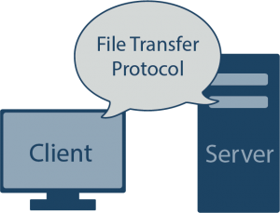

If you have remote employees who need to upload non-confidential information (such as timesheets, for example), or if you want to allow your customers to download white papers and documentation, an FTP Server works well for this purpose. If you are exchanging non-sensitive data with business partners, and the partner requires FTP or SFTP, you can quickly set up a server that will accept their data transfer. Some people even use FTP Servers for offsite backup so they can access their data should something physically happen to their files.